**University of Texas at San Antonio, Department of Electrical and Computer Engineering**

**CPE/EE 4813 Verification and Validation Test Plan, Spring 2023**

Submitted on 04/13/2023





**Project:** Drone Conversion Appliances (DCA)

**Project Manager: Conrad Obeng, fxy380**

**Systems and Software Engineer: Lexi McMinn,yva363**

**Firmware Engineer: Ehab Afsoonko - czu525**

**Software Engineer: Mark James JR.**

**Hardware Engineer: Matthew Moubray**

**Table of Contents**

1 Introduction 2

1.1 Purpose 2

1.2 Project Description 2

1.3 Document Overview 2

2 Applicable Documents 3

3 Testing Methodology 4

3.1 Master Verification and Validation (V&V) Matrix 4

3.2 Testing Types and Methods 5

3.2.1 Verification by Analysis 5

3.2.2 Verification by Demonstration 5

3.2.3 Verification by Inspection 5

3.2.4 Verification by Test 6

3.2.5 Validation by Analysis 6

3.2.6 Validation by Demonstration 6

3.2.7 Validation by Inspection 6

3.2.8 Validation by Test 6

3.3 Master Test Scenario List 6

3.3.1 **TS-DCA_001:Test Flight Preparations** 7

3.3.2 **TS-DCA_002:Full Flight** 7

3.3.3 **TS-DCA_003:Quadcopter Switching** 7

3.3.4 **TS-DCA_004:Module Testing** 7

4 Test Procedures 8

4.1 **TS-DCA_001:Test Flight Preparations** 8

4.1.1 **TC_DCA_VTOL_001** 8

4.1.2 **TC_DCA_VTOL_002** 8

4.1.3 **TC_DCA_VTOL_003** 8

4.1.4 **TC_DCA_VTOL_004**

4.2 **TS-DCA_002:Full Flight**

4.2.1 **TC_DCA_FLIGHT_001**

4.2.2 **TC_DCA_FLIGHT_002**

4.3 **TS-DCA_003:Quadcopter Switching**

4.3.1 **TC_DCA_SWITCH_001**

4.3.2 **TC_DCA_SWITCH_002**

4.4 **TS-DCA_004:Module Testing**

4.4.1 **TC_DCA_MODULE_001**

5 Appendices 9

5.1 xxxxxxx 9

5.2 xxxxxxx 9

5.3 xxxxxxx 9

5.4 xxxxxxx 9

# Introduction

This is the Drone Conversion Appliances Spring 2023 Verification and Validation Test Plan

## Purpose

The purpose of this document is to provide a comprehensive Verification and Validation (V&V) Test Plan of the Spring 2023 Drone Conversion Appliances, including the Project Description, Test Methodology, Verification and Validation Matrices, and Test Cases.

## Project Description

The DCA Project implements a Fixed-Wing VTOL module on the ModiFly drone base. This is done by taking a Sonic Modell Ar Wing Pro wing kit, attaching it to the Modifly drone base, and flashing firmware to the flight controller to allow for Plane modalities. The implemented Fixed-Wing VTOL mode will be a Quadplane Tilt-Rotor. This means there will be 4 arms attached to the drone positioned vertically, and servos connected to the front two arms to transition them downwards by 90 degrees, in a horizontal position. The back two motors will switch off, and forward motion will be provided by the now forward-facing propellers.

## Document Overview

This document is organized as follows:

* Section 2 contains links to relevant and applicable project reference documents and presentations for this Test Plan.
* Section 3 contains a description of the Testing Methodology utilized in this Test Plan, including the Master Verification and Validation Matrix, a description of the 4 types of V&V testing performed, the Test Environments descriptions, and a Master Test Case List of all 4 Test Cases for this project.

# Applicable Documents

This section contains a table of all relevant and applicable project reference documents and presentations for the Drone Conversion Appliances Verification and Validation Test Plan.

| **Document Name** | **Document Description** | **Document Link** |
| --- | --- | --- |
| IEEE Testing Standard | xxxxxxxx | (Paste Google Drive Link here) |
| Initial Design Presentation | Title. Contains xxxxxx | (Paste Google Drive Link here) |
| PRSD | Product Requirements and Specification Document. Contains Contains L0 and L1 Requirements, System Block Diagram, xxxxxx | (Paste Google Drive Link here) |
| Detailed Design Package 1: Critical Design Review | Detailed Design Package Contains xxxxxx | (Paste Google Drive Link here) |
| Final Project Code | Final Document of all MCU Firmware Code. | (Paste Google Drive Link here) |
| Final Project Summary | Final Presentation of completed Project. Contains xxxxxx | (Paste Google Drive Link here) |

# Testing Methodology

This section contains the Master Verification and Validation Matrix, as well as detailed descriptions of the various Test Methods and Test Cases utilized in this Test Plan.

## Master Verification and Validation (V&V) Matrix

This matrix provides complete traceability of every requirement. Specifically, every requirement is mapped to its description, success criteria, V&V testing designation and method, and Test Case(s) where the requirement will be tested. Note that some overlap between Test Cases’ requirements V&V is okay.

| **Requirement Number** | **Requirement Text** | **V&V Success Criteria** | **V&V Designation**  (Verification, Validation?) | **V&V Method**  (Analysis, Demonstration, Inspection, Test?) | **Test Case(s) where Requirement is Tested** |
| --- | --- | --- | --- | --- | --- |
| 1. | VTOL capabilities | Drone in plane mode can vertically take off and land | Validation | Demonstration | TC_DCA_VTOL_001-003 |
| 2. | Easy switch between VTOL and Quadcopter | Under 10 minute switch time between Quadcopter and VTOL mode | Validation | Demonstration | TS_DCA_FLIGHT_001-002 |
| 3. | Extended flight time in VTOL mode | Drone in VTOL mode can stay in the air at least 1.5x longer than drone in Quadcopter mode | Verification | Test | TC_DCA_VTOL_004-005 |
| 4. | Backwards compatibility with old Modifly attachments | All previous Modifly attachments work with new drone | Validation | Test | TC_DCA_MODULE_001 |
| 5. | Autopilot capabilities | Drone can fly without manual input | Validation | Test | [WILL NOT BE TESTED] |
|  |  |  |  |  |  |
|  |  |  |  |  |  |
|  |  |  |  |  |  |
|  |  |  |  |  |  |
|  |  |  |  |  |  |

## Testing Types and Methods

This subsection contains the 4 types of Verification and Validation (V&V) testing. (modified from: NASA Systems Engineering Handbook 2007).

**Verification** proves that a realized product for any system model within the system structure conforms to the build-to requirements (for software elements) or realize-to specifications and design descriptive documents (for hardware elements, manual procedures, or composite products of hardware, software, and manual procedures). In other words, Verification is engineering/technical requirements/specifications driven; verification shows proof of compliance with requirements; that the product can meet each “shall/will” statement as proven through performance of a test, analysis, inspection, or demonstration.

**Validation** is conducted under realistic conditions (or simulated conditions) on any end product for the purpose of determining the effectiveness and suitability of the product for use in mission operations by typical users; and the evaluation of the results of such tests. Testing is the detailed quantifying method of both verification and validation. However, testing is required to validate final end products to be produced and deployed. In other words, Validation is Product/Marketing Requirements driven; validation shows that the product accomplishes the intended purpose in the intended environment; that product meets the expectations of the customer and other stakeholders as shown through performance of a test, analysis, inspection, or demonstration.

### Verification by Analysis

The use of mathematical modeling and analytical techniques to predict the suitability of a design to stakeholder expectations based on calculated data or data derived from lower system structure end product verifications. Analysis is generally used when a prototype; engineering model; or fabricated, assembled, and integrated product is not available. Analysis includes the use of modeling and simulation as analytical tools. A model is a mathematical representation of reality. A simulation is the manipulation of a model.

### Verification by Demonstration

Showing that the use of an end product achieves the individual specified requirement. It is generally a basic confirmation of performance capability, differentiated from testing by the lack of detailed data gathering. Demonstrations can involve the use of physical models or mockups; for example, a requirement that all controls shall be reachable by the pilot could be verified by having a pilot perform flight-related tasks in a cockpit mockup or simulator. A demonstration could also be the actual operation of the end product by highly qualified personnel, such as test pilots, who perform a one-time event that demonstrates a capability to operate at extreme limits of system performance, an operation not normally expected from a representative operational pilot.

### Verification by Inspection

The visual examination of a realized end product. Inspection is generally used to verify physical design features or specific manufacturer identification. For example, if there is a requirement that the safety arming pin has a red flag with the words “Remove Before Flight” stenciled on the flag in black letters, a visual inspection of the arming pin flag can be used to determine if this requirement was met.

### Verification by Test

The use of an end product to obtain detailed data needed to verify performance, or provide sufficient information to verify performance through further analysis. Testing can be conducted on final end products, breadboards, brass boards or prototypes. Testing produces data at discrete points for each specified requirement under controlled conditions and is the most resource-intensive verification/validation technique. As the saying goes, “Test as you fly, and fly as you test.” (See Subsection 5.3.2.5.).

### Validation by Analysis

The use of mathematical modeling and analytical techniques to predict the suitability of a design to stakeholder expectations based on calculated data or data derived from lower system structure end product validations. It is generally used when a prototype; engineering model; or fabricated, assembled, and integrated product is not available. Analysis includes the use of both modeling and simulation.

### Validation by Demonstration

The use of a realized end product to show that a set of stakeholder expectations can be achieved. It is generally used for a basic confirmation of performance capability and is differentiated from testing by the lack of detailed data gathering. Validation is done under realistic conditions for any end product within the system structure for the purpose of determining the effectiveness and suitability of the product for use in NASA missions or mission support by typical users and evaluating the results of such tests.

### Validation by Inspection

The visual examination of a realized end product. It is generally used to validate physical design features or specific manufacturer identification.

### Validation by Test

The use of a realized end product to obtain detailed data to validate performance or to provide sufficient information to validate performance through further analysis. Testing is the detailed quantifying method of both verification and validation but it is required in order to validate final end products to be produced and deployed.

## Master Test Scenario List

A **Test Case** can be described as *a scenario containing a sequence of detailed test steps, in order to perform verification/validation testing on multiple requirements that are similar in nature.*

For example, if a group has multiple requirements regarding starting up their robot project, they can group all these requirements to be verified/validated in a single test scenario. Similarly, if a group has multiple requirements that can be verified/validated via inspection, they can group all of them together in a single test scenario.

The purpose of this subsection is to provide a High-Level overview of all Test Scenarios utilized in this Test Plan. Each item in this subsection will contain the following: Test Scenario Number and Name, High Level Scenario Description, and Test Environment Description.

### TS-DCA_001:Test Flight Preparations

Description: All procedures necessary to ensure a safe and successful initial test flight.

Test Environment: Inside

### TS-DCA_002:Full Flight

Description: Testing of Fixed-Wing VTOL flight in an outdoor environment.

Test Environment: Outside

### TS-DCA_003:Quadcopter Switching

Description: Testing speed of switching between VTOL Fixed-Wing and Quadcopter modes.

Test Environment: Inside

### TS-DCA_004:Module Testing

Description: Checking backwards compatibility of Modifly modules.

Test Environment: Inside

# Test Procedures

This section contains details of every Test Scenario utilized for V&V of project requirements. Each Test Scenario subsection within this section will contain the following: Test Scenario number and name, detailed scenario description, Test Scenario Traceability Matrix, detailed success criteria, detailed Test Environment description, Test Assumptions/Preconditions, Detailed Test Procedure Steps, and a Pass/Fail Matrix of success criteria per Test Senario.

## TS-DCA_001:Test Flight Preparations

### TC_DCA_VTOL_001

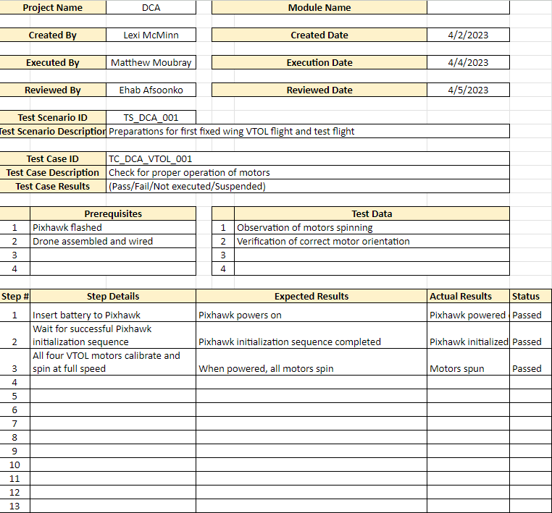

### TC_DCA_VTOL_002

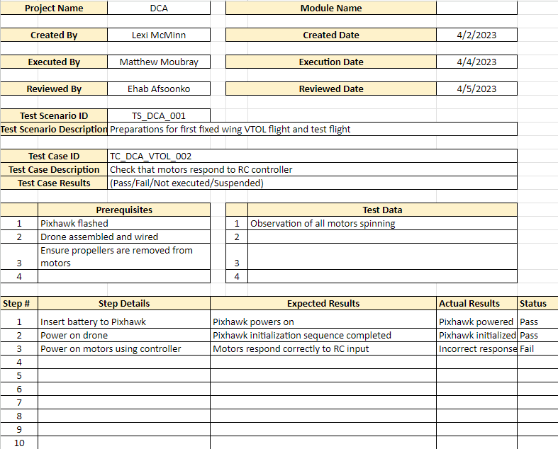

### TC_DCA_VTOL_003

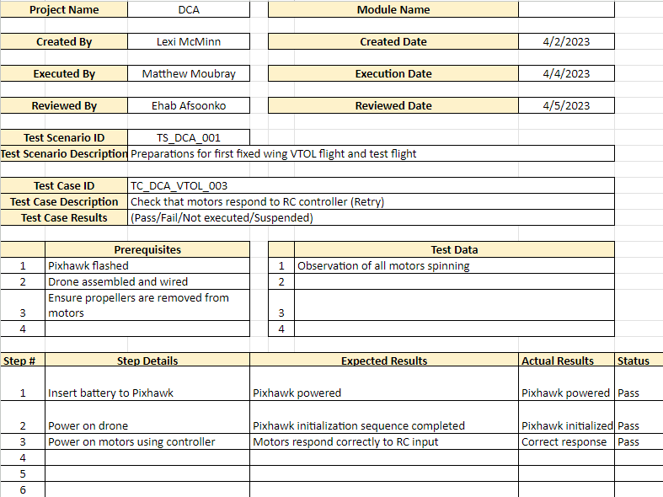

### TC_DCA_VTOL_004

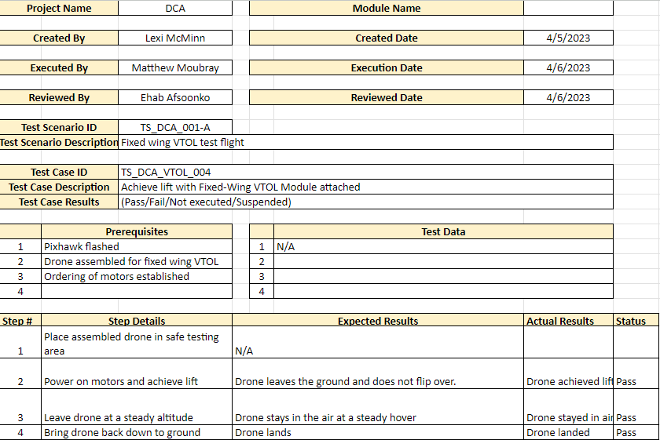

### TC_DCA_VTOL_005

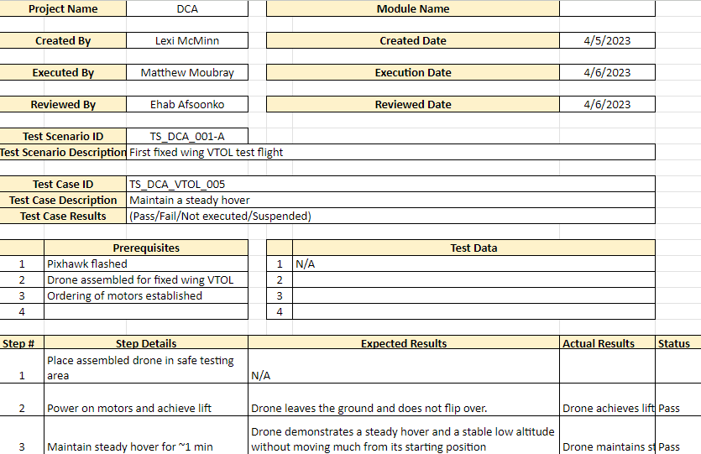

## TS-DCA_002:Full Flight

### TC_DCA_FLIGHT_001

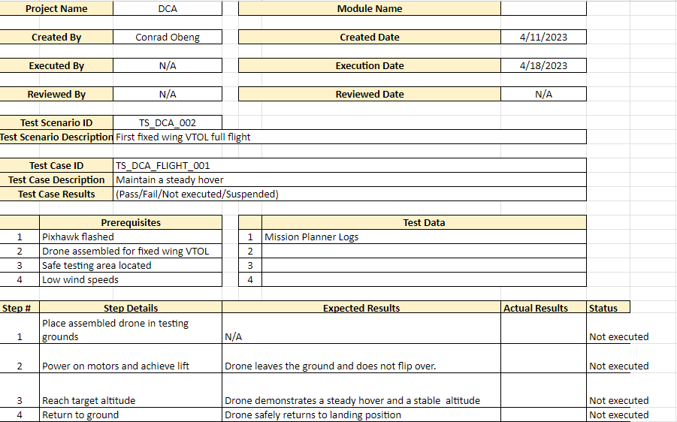

### TC_DCA_FLIGHT_002

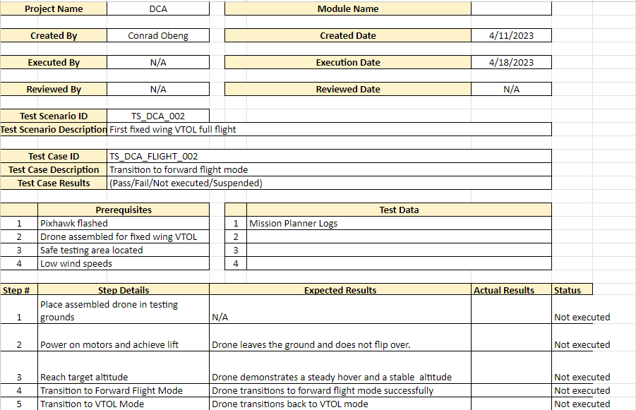

## TS-DCA_003:Quadcopter Switching

### TC_DCA_SWITCH_001

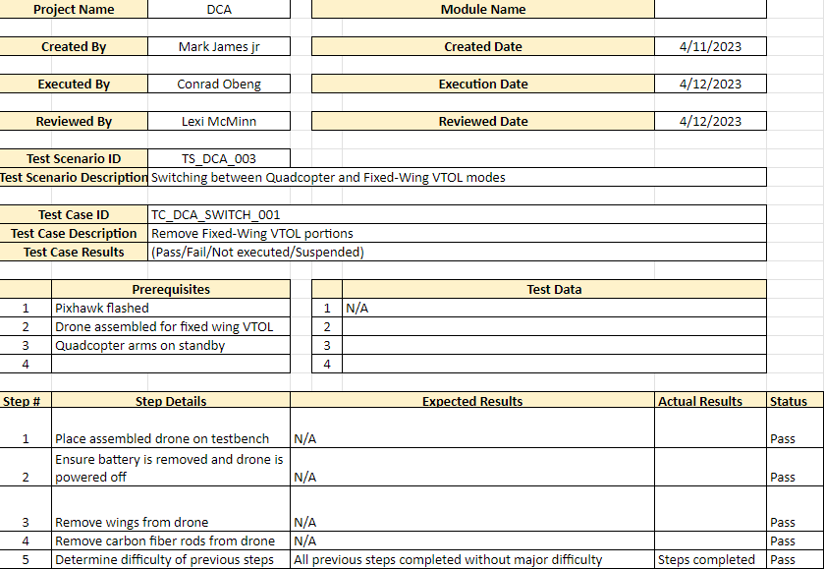

### TC_DCA_SWITCH_002

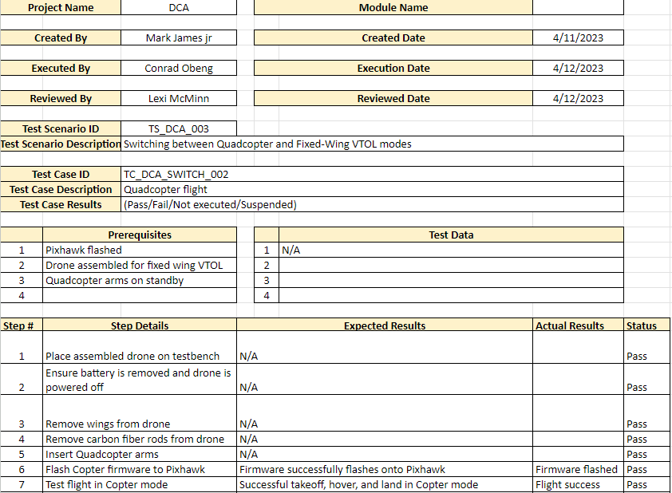

## TS-DCA_004:Module Testing

### TC_DCA_MODULE_001

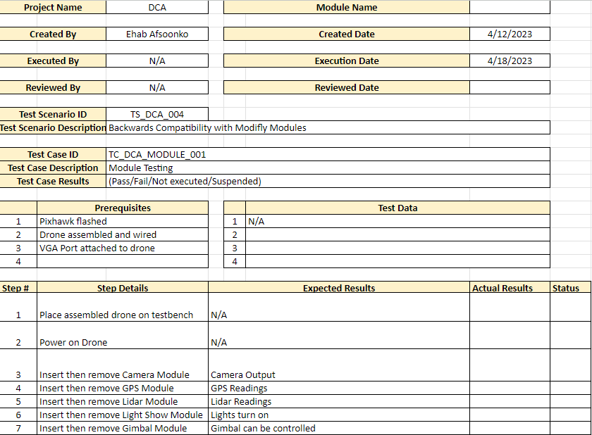

# Appendices

This section will contain any addition documentation needed to verify/validate requirements. For example, if a project has a cost constraint requirement, include the cost breakdown spreadsheet below as a subsection and reference the appendix subsection in the related Test Step in the Test Procedure. If another group needs to verify something by hand via calculation, include the calculations as a subsection below and reference the appendix subsection in the related Test Step in the Test Procedure.

## xxxxxxx

## xxxxxxx

## xxxxxxx

## xxxxxxx